Team B Members: Aman Ahmed, Fahim Ahmed, Zineddine Daif, Ali Elzalmy, Coreen John, Aaron Meressie, Benji Misner, Ahmed Mohamed

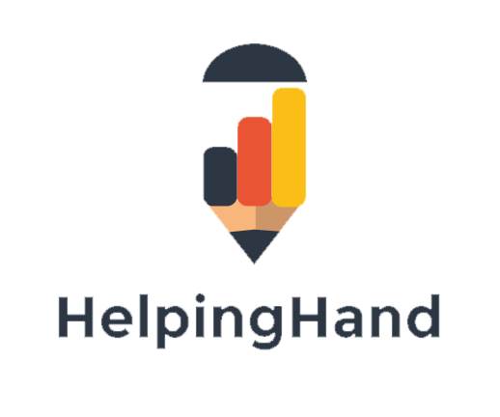

**Team B**

**Software Project Proposal**

**Table of Contents**

1. User Need Overview & Concept Introduction 1

2. Data gathering and requirements 2

2.1. Identification of Stakeholders 2

2.2. SWOT analysis 3

2.3. Revenue Model 4

2.4. Business Model Canvas 6

3. Functional Specification 13

4. Ethical audit 13

5. Design 14

6. Prototyping 16

7. Technical Architecture 18

8. Evaluation Plan 21

9. Project management 21

9.1. Weekly meetings 21

9.2. Weekly project tracking 21

9.2.1. Trello 22

9.2.2. Zoho 24

10. Conclusion 28

11. Bibliography 29

12. Appendices 31

Appendix A. Identifying user needs 32

Appendix B. Identifying Stakeholders 33

Appendix C. Storyboards to identify potential stakeholders 40

Appendix D. Results of functional prototype 46

Appendix E. Technical prototyping – MVP 62

Appendix F. Minutes of weekly meetings 74

**Table of figures**

Figure 1: HelpingHand Revenue model 5

Figure 2: Business Model Canvas 6

Figure 3: Segmentation of business canvas 7

Figure 4: Key flow between value proposition and customer relationship 8

Figure 5: Key flow between value proposition/customer segments and revenue streams 9

Figure 6: Key flows between Key activities and value proposition 10

Figure 7: Key flows between Key activities and key resources 11

Figure 8: Key flows between key activities and cost structure 12

Figure 9: UML diagram of tutoring system 15

Figure 10: Conceptual prototype mock up 17

Figure 11: Central Repository) 19

Figure 12: MVC Model 20

Figure 13: Trello project management software 23

Figure 14: Project Milestones 25

Figure 15: Task Progress Chart 26

Figure 16: Gantt Chart 27

Figure 17: Brainstorm of business ideas 32

Figure 18: Diagram identifying stakeholders 33

Figure 19: Story Board - Parent Persona 41

Figure 20: University Student storyboard 42

Figure 21: Account Selection screen 47

Figure 22: Login screen 48

Figure 23: Account creation 49

Figure 24: Profile page of student 50

Figure 25: New job selection 51

Figure 26: Instant message page 52

Figure 27: Feedback page 53

Figure 28: Logo Feedback 61

Figure 29: Name Feedback 61

Figure 30: Home page of technical prototype 62

Figure 31: Welcome page for parents 63

Figure 32: Profile of child and teaching requirements 64

Figure 33: Selection options 65

Figure 34: Acknowledgement page 66

Figure 35: Welcome page for tutor login 67

Figure 36: Tutor login page 68

Figure 37: Profile page of tutor 69

Figure 38: Previous jobs that have completed by the tutpr 70

Figure 39: Welcome page for tutor 71

Figure 40: Job selection page 72

Figure 41: Job categories for tutors 73

Table 1: SWOT analysis 3

Table 2: Analysis of stakeholder identification 34

Table 3: School Child Persona 43

Table 4: University Student Persona 44

Table 5: Parent persona 45

Table 6: Parent prototype feedback 54

Table 7: Minutes of meeting (6 October 2017) 74

Table 8: Minutes of meeting (13 October 2017) 76

Table 9: Minutes of meeting (20 October 2017) 77

Table 10: Minutes of meeting (3 November 2017) 79

Table 11: Minutes of meeting (10 November 2017) 81

Table 12: Minutes of meeting (17 November 2017) 83

# User Need Overview & Concept Introduction

The tutoring industry is currently valued at £2m (Guardian, 2016), 40% of private tutoring was used by children in London and 1 in 10, 11-16 years old received private tutoring in England and Wales (Guardian, 2016). There seems to be a trend (Guardian 2016) towards more affluent families being able to provide their children with the option of having a private tutor to enhance and complement their education. This has alerted The Sutton Trust a charitable organisation aimed at increasing social mobility through education warns that at some point increase the inequalities of education for less affluent students (Guardian, 2016). The Sutton Trust an education charity has suggested that the Government should introduce a means-tested system to enable less advantaged children to benefit from private tutoring and close the education knowledge gap.

In order to help close this learning gap that has been created by more affluent students being able to access private tutoring, HelpingHand is an innovative connection tool that aims to solve the education need for children who may need assistance in their learning by enabling parents to make a connection with a university student who can offer tutoring services to children who may need additional help with tutoring at a cost effective price. This can include but is not limited to language assistance, subject assistance (help with maths, reading, science etc.). Parents can use the service to connect with a university student who can offer their child tuition in the subject that the child needs assistance with.

HelpingHand’s aim is to be:

“*A tool to assist children who are struggling with their learning*”.

The inspirations for the look of the HelpingHand concept were formed as follows:

Tinder: multiple logons with various accounts which would make it easier for users to logon to the system in mind, synchronisation of profiles and preferences. The “swipe to like” design which could be incorporated for parents and tutors. HelpingHand can use the log in synching aspect of Tinder for easy login for the university students.

Amazon prime: A pointer system for location based services which could be incorporated so you can see locations of a potential tutor. A rating system is used which could be incorporated to rate the services of the tutor with details of pricing also attached. This could be incorporated so parents can see where there is a tutor available in their local vicinity.

Quick: is a home help system which matches students and elderly people. The app contains an interactive map interface which is easily accessible it also incorporates voice recognition and has a, rating system. All features which HelpingHand can adapt.

# Data gathering and requirements

## Identification of Stakeholders

The table shown at Appendix B below identifies the key stakeholders who will help shape and equip the project for success. The roles of each stakeholder differ according to which stakeholders are involved in the decision-making process and how to communicate, cooperate and associate with them etc.

The stakeholders that have been identified are:

*Internal Stakeholders*

University Students

University students may want a facility where they can earn money whilst studying by utilising their knowledge base to tutor children. The platform will require the student to log in their university credentials to confirm authenticity. The student will then be able to find local jobs to help tutoring jobs. The student will then be able to tutor, and earn an income.

Parents

Parents have been identified as an internal stakeholder as they will be the main users of the HelpingHand platform. The parents will use the platform to logon and create a user profile and this will then give the ability to search for a suitable tutor for their child’s needs.

*External / Other Stakeholders*

Schools

Many schools have interactive learning portals, where parents can see student profiles, displaying student academic information such as reports, as well as homework. Schools could partner with the platform, giving them University ‘tutor’ access to the data, allowing them to further help the child by being able to prepare student specific learning.

Government / Local council

These entities have been identified as it may be possible to gain sponsorship to help sustain the business.

Retailers

Retailers have been identified as a target market as many of the retailers run schemes supporting local businesses and ideas, where contributions are made to provide financial aid to these organisations. Waitrose for example run a community matters scheme, where after each purchase the customer is given a token, to which they can then ‘vote’ which percentage of the monthly charity allowance (£1000 for large branches, £500 for express branches) goes to which organisation. Our application could apply to one of these schemes, providing funding and support.

Various types of resources were used to identify who the stakeholders would be and these can be found at Appendix B below.

## SWOT analysis

In order to identify the internal and external strengths and weaknesses of the project a swot analysis was devised to highlight and minimise any weaknesses that may become apparent later on in the development phase of the project. Please see Table 1: SWOT analysis below.

Table : SWOT analysis

|  |  |
| --- | --- |
| Strengths | Weaknesses |
| * A tool to connect parents with university students offering tutoring services to children * Cost effective for parents * Skill and knowledge building for university student. * Can be offered as a charitable service. * Children reaching their maximum potential through tuitions. * Instant messaging between parent and tutor. | * Concrete understanding of technical development language. * Unavailability of Tutors at a time of demand. * Tutors little relevance of work experience. * No clear guidelines on how to measure child’s progress of tuition. * No clear guidance giving on how service works and how it’s used by parent or tutor. * On demand support or contact details for parents should they have trouble with service. |
| Opportunities | Threats |
| * Sponsorship from supermarkets * Charitable status * Recruit more Tutors from other London universities * Reduced tuition costs enabling less advantaged children to benefit from service * Expand service across other major cities in England * Include other age demographics of end users (children) | * More skilled Tutors with competitors * Decreased market demand due to advances in teaching via technology * Parent dissatisfaction of service causing bad review and other potential users to reconsider * Poor management strategies for Tutors * Tutors have not passed DBS checks * Lack of brand exposure if external stakeholders don’t support project. |

## Revenue Model

The diagram shown at Figure 1: HelpingHand Revenue model below shows how the revenue streams will work. HelpingHand will operate as a Business to Customer (B2C) model. When a tutor and parent connection is made the payment will be handled entirely through the HelpingHand platform. A commission of 10% will be taken for each transaction which will be the main source of income for the business. The business will also rely upon charitable sponsorship from government bodies and from major retailers. Another revenue stream consideration may come from businesses advertising on the platform. Please see Figure 1: HelpingHand Revenue model below.

HelpingHand Revenue model

Charitable/government sponsorship/major retailers

Advertising

Commission from platform transaction

Figure : HelpingHand Revenue model

## Business Model Canvas

The business model canvas has been used to show how the business will be set up and to illustrate how the business processes will flow.



Figure : Business Model Canvas



Figure : Segmentation of business canvas



Figure : Key flow between value proposition and customer relationship



Figure : Key flow between value proposition/customer segments and revenue streams



Figure : Key flows between Key activities and value proposition



Figure : Key flows between Key activities and key resources



Figure : Key flows between key activities and cost structure

# Functional Specification

One of the main function elements will be a using is an algorithm that queries information to the database, based on keywords. Our data is extremely structured and thus it will be easy to query so an algorithm based on keyword matching or just a sorting query database would be good. We would use a database that can link with our website so that users can query information from the database. The most efficient way would be to use MySQL or MongoDB as you can easily query data using PHP or JavaScript.

# Ethical audit

In order to address any legal, data protection or any other legal implications an ethical audit was conducted as follows:

*DBS Check:*

All jobs in the UK that involve working with children require a DBS check to be carried out this is a detailed police check to ensure that the person that is being checked does not have any restrictions on their ability to work with children. Every potential tutor also needs to have their identity verified. It is still being investigated whether university authentication when logging on to the system will be sufficient.

*Confidentiality Agreement*

If required a parent could request that the Tutor signs a confidentiality agreement in order to protect the interests of the client(s). The confidentiality agreement would ensure that any confidential information of the client will be protected.

As HelpingHand may operate across various platforms the following considerations will have to be made:

*Apple Developer Program Agreement*

If HelpingHand utilises the Apple platform, then the Apple Developer Program Agreement can be entered into by paying a fee-based subscription which will allow members to publish apps. The subscription also covers the costs hosting, DRM (Digital Rights Management) protection, and credit card etc. This agreement costs developers £99 a year which is renewable once expired. There is also an intellectual property license which allows for distribution of the app to end users, including hosting and displaying the app, making copies thereof and allowing end user to download the content itself.

*Google Play Licensing*

A Google Play License may be required this is a network-based service that will allow an application query to a trusted Google Play licensing server to determine whether the application is licensed to the current device user. A one-time fee of £25 must be paid to obtain this license.

*End-User License Agreement*

This license may be required to put in place between a user who purchases, installs, or downloads software, and the provider of the software.

*Privacy Policy*

An essential license of the agreements will be required to what personal data will be collected from users. The document will also be used detail how information on users will be handled, and will be used to identify individuals. The privacy policy is required on both iOS and Android platforms. It is also a requirement of Apple and Google.

*Social Media policy and advertising*

There needs to be some consideration taken when advertising the tutoring business as there may be legal implications of how you advertise for example giving out flyers outside of a school playground to parents. There are rules and regulations in place on how you should advertise and not to have misleading advertisements and direct marketing.

# Design

The system design with a simple interface. This approach has been used to satisfy our target market of parents. The Unified Modelling Language (“UML”) Figure 9 shows you a step by step representation of how the user will interact with the system.

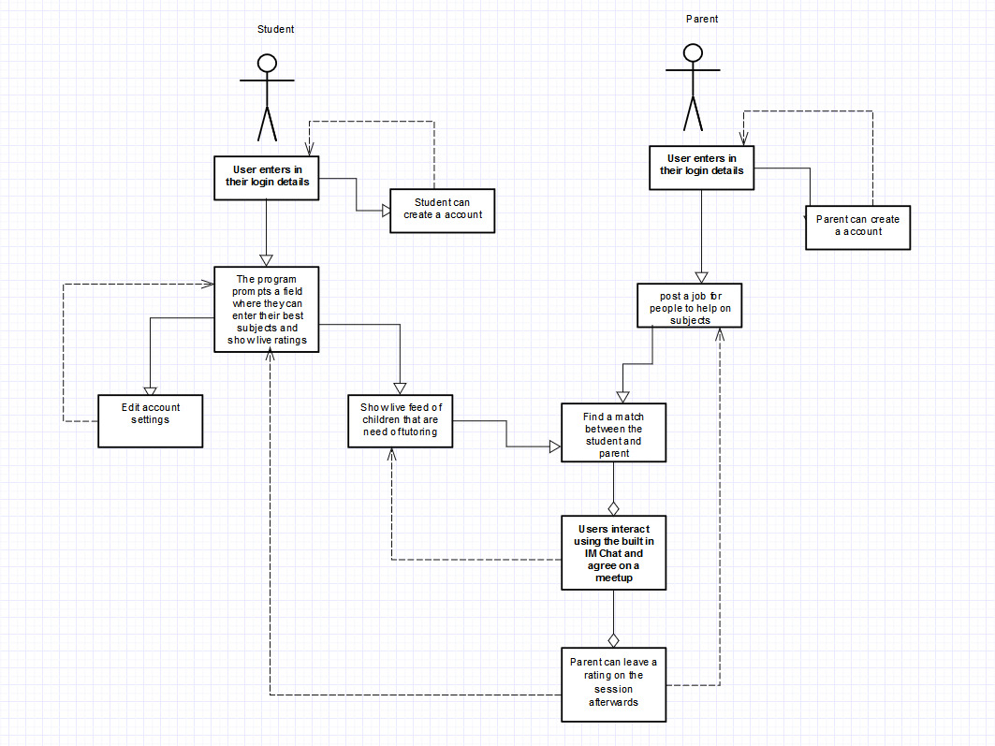

Figure : UML diagram of tutoring system

There are two main usages of the system: Parent and Student. Which will be explained in turn:

**Student:**

When the student enters the system, login details can be entered, if they do not have an existing account a new one can be created. The student’s university credentials are used to verify them as validated users of the system. This system will ensure that only current students are members and it also ensure that their personal details and skills are already validated by their educational institution. There is also an option for the student to edit their user details as follows:

* they can add to or delete their skill sets;
* write short biography;
* add a profile picture;
* to the option to deactivate their account;
* review any accepted applications; and
* check their message history;

Once they have gone through these options, they can start finding suitable job matches according to what they have specified in their credentials and start applying for different job roles. The student can make contact the potential client via a message and agree on their teaching times and also track any earnings they have made.

**Parent:**

When the parent enters the system they will be presented with login details where they can enter their credentials or set up a new user account. The parent will have the ability to view any jobs they have posted and if they have any responses. The parent will also have the ability to view the profiles of the students who have applied for their job request. The parent will then be able to communicate with the student and accept their job request. Feedback can be left for students which will be implemented by a rating system.

The system would use two types of interface: one for the students which will have some modification on the features as they will need to enter more information for verification purposes. The parents’ user interface will have less advanced features. To ensure that our users are not limited in their usage and accessibility a multi-lingual feature will be added as well as a voice recognition feature. This will be additional accessibility feature for the parents if they want to speak rather than write.

# Prototyping

In order to test the viability of the project we used a three step process to test the prototype.

Step 1: Conceptual Prototype

A wireframe mock-up (see Figure 10: Conceptual prototype mock up below) was created so that we could seek initial feedback from our potential stakeholders and users of the system. This step helped to establish how the project could be developed further.

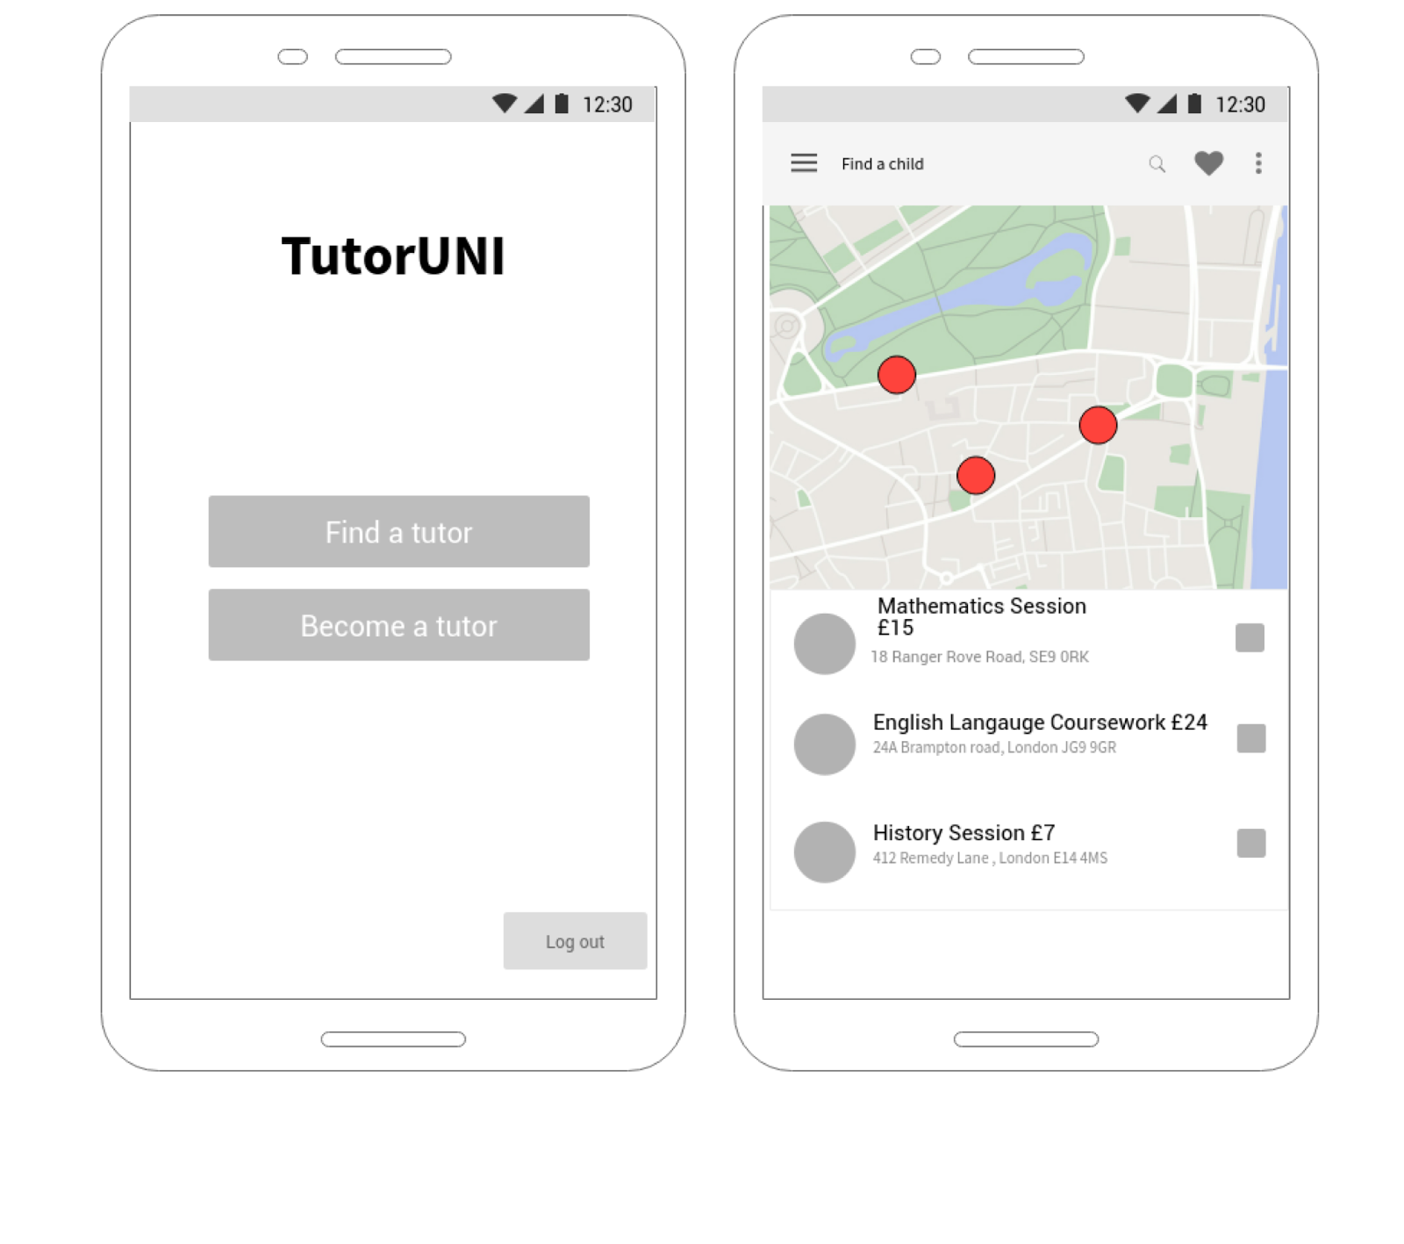

Figure : Conceptual prototype mock up

Step 2: Functional Prototype

In order to test the potential functionality of the project, the two identified users were split into two groups.

*Student and Parent users:*

In order to test Student and Parent users a prototype was used which tested the validity of the user interface. The prototype was conducted in the form of a Powerpoint presentation which had some very basic interactivity. This allowed the user to make basic click functions to see how the functionality of the potential website worked. The functional prototype also had a built in survey so that live feedback could be collaborated whilst they engaged with the Powerpoint presentation. The prototype helped to establish how the interface could be redesigned to ensure that the needs of the users are met.

Please see Appendix A below for a full breakdown of the results of the functional prototype.

Step 3: Technical Prototype - Minimal Viable Product

As well as testing user interactivity, it was also important to establish the technical requirements of the project. So, in order to test the technical aspect a Minimal Viable Product (using a JQuery application) was built in order to test our targeted end users so that we could gain feedback and make any necessary changes they felt could help improve our product. Implementing a MVP was an efficient way of testing and answering the technical questions that needed to be addressed for the project.

The users in which we targeted and approached were university students. The research found that 67%of the users were quite satisfied with the functional prototype they felt the interaction and design of the product suited the concept well. The feedback also gave insight on the users understanding and realization of the initiative behind having University students as tutors for the project. From these findings, the final product will include sufficient features to satisfy early adopters, the ideology was fully backed in solving the education need for children who may have a gap in their learning.

For the remaining 33% of the targeted groups who tested the MVP were not as confident about the viability of the platform. The early adopters felt ‘confused’ when using the product as they could not quite understand the steps on how the overall service works. This feedback will be used to make changes to the platform. The target group recommended that an inclusion of a short guide at the beginning of the application or even on every single page which would help users better understand the process and to fully utilise all the products features.

Please see Appendix E below for a full breakdown of the results of the technical prototype.

# Technical Architecture

In order to validate the technical architectural structure of our design, two architectural diagrams (see Figure 11: Central Repository and Figure 12: MVC Model below) have been designed to justify the choice of technologies that will be implemented.

Central Repository:

It is important that we have a central repository as with our software, the database that holds data and involves the different processes such as chat system in the software is linked to the central repository as that would hold the chat history as well as the user info. Another example would be the different java scripts that are executed such as on the web app displaying the user info, would need to link back to the central repository as it would need to access user information once again.

/Users/coreenanderson/Google Drive/Business Computing 2017-2018/Software Projects 2017-18/Architectural Diagram/Central Repository Diagram.pdf

Figure : Central Repository)

Model View Controller (“MVC”):

The MVC diagram has been used to highlight the database interactions that the system will use.

*Model:*

The relational database will be responsible for managing the data of the application. The relational database will handle instruction responses from the controller to update itself.

*View:*

The view will present the data in the form of jobs that have been posted, parental requests for a tutor request.

*Controller:*

The controller will respond to the user input. The controller will receive job postings, instant message between the parent and the tutor. It will also handle login details from the two interactors using algorithms(?).

The diagram also illustrates the output and input requests and shows what the data flows are within the system.

/Users/coreenanderson/Google Drive/Business Computing 2017-2018/Software Projects 2017-18/Architectural Diagram/MVC.pdf

Figure : MVC Model

# Evaluation Plan

We intend to evaluate our project using a systematic software release cycle that enables us to push the product through different stages of development. This will help establish early refinements to the platform from the initial idea to a fully completed high-end platform achieved through user-led modifications.

Three test cases will be implemented as follows:

*Test case 1:*

An alpha version of the product will be produced in which the application will be running with limited functionality, this will be used for debugging purposes. Once the platform has been developed it will be rolled out to our users for testing. The feedback will be collated and the outcome will be incorporated for further product developments.

*Test case 2:*

A beta version of the platform will be released, any issues that occurred in test case 1 will be rectified. This will be rolled out to end users and the feedback received will be used to incorporate any changes, thorough debugging and to add any additional functionality.

*Test Case 3:*

The final test case will be used to release the final product. At this stage the platform will have gone through a cycle of rigorous quality control and all major technical issues will have been identified and resolved. The platform will be fully functional, debugged and ready for release to end users.

# Project management

In order to effectively manage the project various process have been implemented as follows:

## Weekly meetings

In order to ensure that there was full team cooperation and to ensure that team decisions about the project were captured efficiently. Weekly team meetings were held, (please see Appendix F below for weekly minutes of the meeting).

## Weekly project tracking

In order to track the project and ensure that the team was aware of major milestones and to analyse the critical paths of the project a number of management tools were utilised as follows:

## Trello

Trello has been used in order to set tasks for the team to complete. This platform was useful in ensuring that all of our tasks were accessed in one central place (please see Figure 13: Trello project management software below.

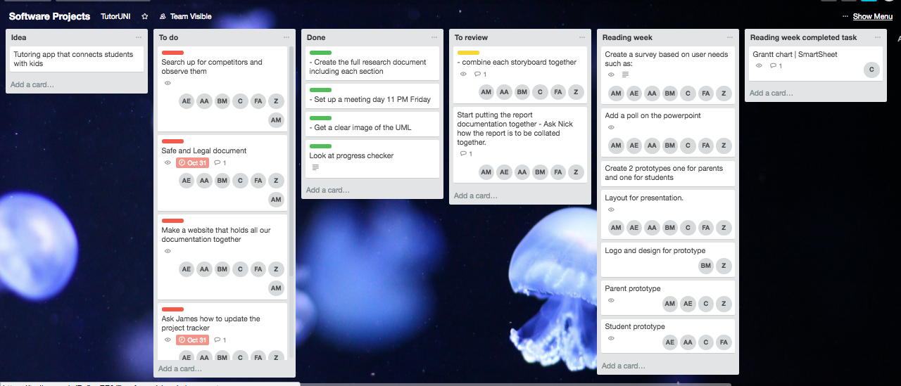

Figure : Trello project management software

## Zoho

The project management tool Zoho was used in order to set project milestones and to analyse the critical paths of the project. This tool was equipped to enable efficient project management.

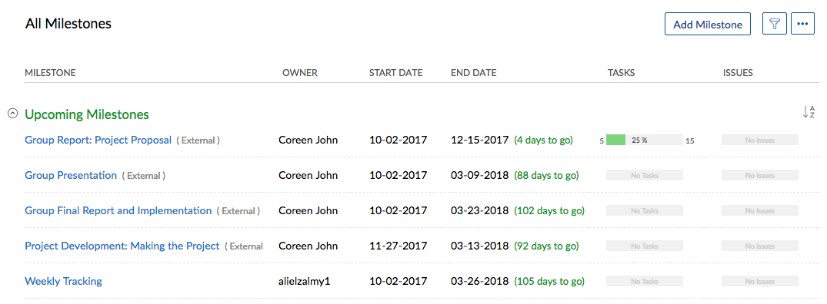

Figure : Project Milestones

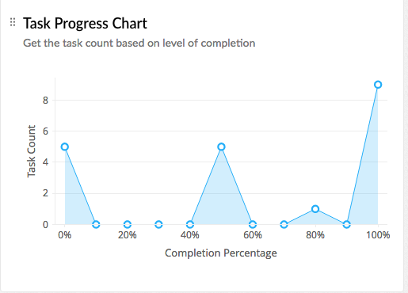

Figure : Task Progress Chart

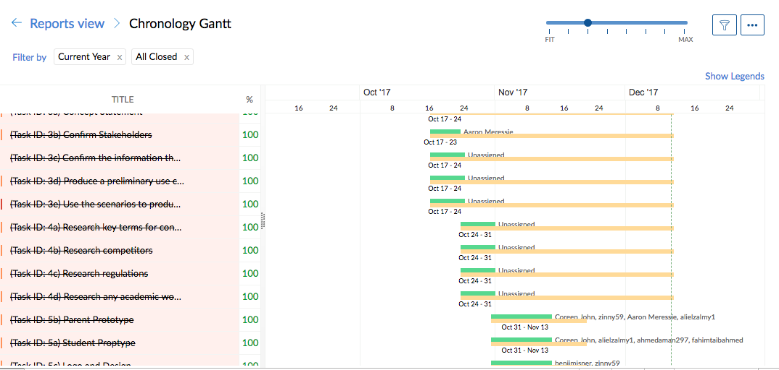

Figure : Gantt Chart

# Conclusion

HelpingHand is an innovative connection tool that aims to solve the education need for children who may need assistance in their learning by enabling parents to make a connection with a university student. Students will offer tutoring services at a cost-effective price. The project will support children to reach their maximum potential and through this achievement it can also be offered as a charitable service. The main source of revenue will come in the form of 10% commission from each transaction made. The project will try and source charitable sponsorship from government bodies and major retailers as an alternative revenue stream.

The system architecture is logically planned in order to achieve a simple user interface that will benefit end users. The technical functionalities with the use of a central repository that can hold substantial data of potential users. A database will be used as a connection with the application so that users can query information from the database. Algorithms will be used to query information within the database which will match keywords selected by users on the platform. The project concept has the potential to succeed within its market, this has been proved by carrying out thorough market research and testing early adopters using a technical prototype (which had very positive feedback), reinforces the viability of the project.

(Word count: [3623])

# Bibliography

Alvia (2017) *How much do Uber drives make in 2017?* [Online]. Available at: <http://www.alvia.com/how-much-do-uber-drivers-make/> [Accessed: 21 October 2017].

Apple (2017) How the Program Works, *Apple Developer Program* [Online]. Available at: <https://developer.apple.com/programs/how-it-works/> [Accessed: 28 October 2017].

Apple (2017) Software License Agreements, *Legal* [Online]. Available at: <https://www.apple.com/uk/legal/sla/> [Accessed 28 October 2017].

Clever Prototypes LLC, *StoryBoard That* [Online]. Available at: <https://www.storyboardthat.com> [Accessed: 18 October 2017].

Hosie, E (2017)Legal considerations when starting a tutoring business. *Time Cruncher* [Online]. Available at: [https://tutorcruncher.com/legal-implications-when-starting-a-tutoring-business/] [Accessed: 26 October 2017].

Keystone Tutors (2017) Child Protection Policy [Online]. Available at: <https://www.keystonetutors.com/policies> [Accessed: 28 October 2017].

Gil, N (2014) One in seven students work full-time while they study. *The* *Guardian.* [Online]. <https://www.theguardian.com/education/2014/aug/11/students-work-part-time-employability> [Accessed: 23 October 2017].

Google (2017) App Licensing *Google Services* [Online]. Available at: <https://developer.android.com/google/play/licensing/index.html> [Accessed: 28 October 2017].

Government (2017) Privacy Policy. [Online]. Available at: <https://www.gov.uk/help/privacy-policy> [Accessed: 28 October 2017].

Morrison, N (2015) Sharing the Benefits of Private Tutoring. *Forbes.* [Online]. Available at:<https://www.forbes.com/sites/nickmorrison/2015/08/11/sharing-the-benefits-of-private-tutoring/#469db0f0631b>

Shutterstock (2017) [Online]. Available at: <https://www.shutterstock.com/video/clip-3204130-stock-footage-a-man-and-his-son-spending-some-time-together-at-home-reading-a-book.html> [Accessed 9 December 2017].

Weale, S (2016) Sharp rise in children receiving private tuition, *The Guardian*. [Online]. Available at https://www.theguardian.com/education/2016/sep/08/sharp-rise-in-children-receiving-private-tuition [Accessed: 23 October 2017].

# Appendices

#### Identifying user needs

In order to develop project ideas we went through a process of brainstorming which helped identify potential business ideas.

|  |
| --- |
| ./../../../Google%20Drive/Software%20Projects% |
| ./../../../Google%20Drive/Software%20Projects% |
| ./../../Brainstorm4.jpeg  Figure : Brainstorm of business ideas |

#### Identifying Stakeholders

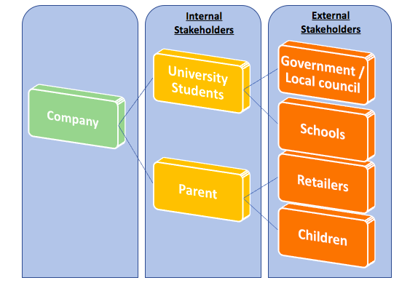

Figure : Diagram identifying stakeholders

Stakeholders analysis diagram shown above identifying project stakeholders, how their needs may impact the project, and the contributions that the stakeholders will make to the requirements throughout the process.

**Stakeholder Analysis**

Table : Analysis of stakeholder identification

| **Stakeholder** | **Role of Stakeholder** | **Benefits on projects** | **Impact on projects execution** | | **Action requirements** |
| --- | --- | --- | --- | --- | --- |
| **Negative** | **Positive** |
| University Student | These stakeholders are considered as valuable members to this project. Acting as our primary market, individuals from this group are assigned jobs via the mobile app based on their availability and location from users. These jobs consist of one-to-one tutoring interactions with younger students in need of extra help with their school work in their homes. | * + Knowledge of high academic standards can be shared and taught to children.   + Flexibility/convenience with job offers and being able to offer their support instantaneously * Will give the university student valuable work experience that they would not necessarily attain if they were not using the application. | * + Help children maximise their learning potential.   + Offer the necessary assistance in areas which child is facing difficulties with.   + Provide the role of a good disciplinarian in a student’s life. | * + Lack of knowledge in working with children   + Unable to connect with families to advise on child’s progress   + Not familiarised with new school curriculum reforms | * + Awareness on working with children.   + Liaising with parent to be well informed of child’s support program.   + Take into account the awareness of child’s school curriculum reforms. |
| Children | These are our targeted end users ranging from the ages of 11-16 (years 7-11). Those from this group will be the project's main focal point in supporting their educational needs and helping achieve improved grades towards their GCSE qualification. The users will be able to connect with academic specialists, from the field of interest, within their proximity to provide private tutoring sessions. | * + Loyalty – more likely to be a source of repeat business and to recommend the service to friends and family   + Enhanced public image – helps build our brand and provides protection if there is a slip-up in overall service delivery   + More effective workforce – satisfied results of children’s education progress in school can help create a positive working environment. | * + Improved academic results.   + Confidence established in their abilities of supported subjects.   + Freedom from external problems and situations such as bullies, peer pressure and even boredom. | * + Learning difficulties   + Burden of extra home work along with that which is given from the school   + Students may have limited involvement in team sports and other extra-curricular activities outside of school. | * + Addressing and adhering to any learning difficulty child may face before tutoring begins.   + Support offered will include any assignments/homework child is given from school.   + Tutoring session will have to be agreed based on child and family’s availability. |
| Parents | Considered as our secondary focal point from the children, these members will be able to connect with academic specialist via the mobile app by identifying the support that will be offered to their kids and also notice how safe their kids are with adults they do not know. | * + Better tuition interaction - ability to contact parents directly would benefit from overall teaching experience.   + Safeguarding security – involvement of parents would address consent needed for academic specialist to support their children. | * + Better outcome for students’ progress.   + The focus of child can be on studying. | * + Time – tutoring can absorb a substantial amount of a parent’s time.   + Financial restrictions – not all families might be able to afford service if family income is already low. | * + Tutoring session will have to be agreed based on parent's and child’s availability.   + Draw up a plan to market service at an affordable price range for all families. |
| Schools | This project will include the involvement of public schools in London to gain expert insight on the service and also to tailor the tutoring to the specific course materials that is offered. | * + Creating excellent word of mouth promotion of services - sell services to other students who may be of interest.   + Provide analysis on concepts and knowledge of what works best with certain types of students i.e. learning difficulties, attention span etc. | * + Gaining official approval from established public school.   + Enhance overall tutoring experience for child.   + Addressing current rules and regulations of exams and assessments. | * + Child’s learning habits/techniques may change through tutoring | * + To develop and maintain child’s way of learning and understanding new study techniques through specialized handout material to explain difficult concepts using easy-to-understand ideas and examples. |
| Government/Local Council | This group’s inclusion within the project would primarily be to seek development of our business plan with financial and other supporting information. | * + Building a public profile - Gain media attention which could lead to public recognition.   + Free advice – providing signposting, diagnostic support and business improvement guidance. | * + Financial Support – government-backed grants.   + Business support e.g. mentoring, consultancy. | * + Interference with business plan – changes in policies and procedures | * + Set terms limits for all government partnering officials |
| Retailers | The position of this group within the project would be to attain a greater exposure of our target market and to utilise other marketing opportunities from their involvement e.g. school/loyalty vouchers. | * + Boost brand awareness - people will become familiar with our brand and reputation this includes local communities   + Resources available to gather feedback on current business environment/ market and use to improve/refine/develop service offer in order to remain competitive and sustainable | * + Attract both tutors and children who will benefit from service.   + Reduce promotional and advertising costs. | * + No control on product presentation to target market.   + May offer poor customer service potentially harming our brand image. | * + Adopt guidelines for partners to control brand image and positioning of our core principles/standards |

#### Storyboards to identify potential stakeholders



Figure : Story Board - Parent Persona



Figure : University Student storyboard

**Personas**

Table : School Child Persona

|  |  |
| --- | --- |
| **Persona** | School child |
| **Photo** | https://lh6.googleusercontent.com/0254U7RGMQpdCDKxu8IVb0Lr3dFZEs0A2g4Q3FzP8oIZvtsxl0ETH0Suw2zVPEESTZhYT7IKYPZVz0i-wa6cuCg8fmMZ5J4SnifaEW3fl5uMGFCH5aMq4ClNciThKCLZyAMqSrT_ |
| **Fictional name** | Jimmy Stone |
| **Job title /major responsibilities:** | School student |
| **Demographics:** | Age 12 (UK)  Male  Lives at home with Mum, Dad & younger Sister  Goes to secondary school |
| **Goals and tasks:** | Jimmy is Year 8 and is struggling at school with his Maths homework, he wants to do well at school but just needs some additional help with his schoolwork.  His parents struggle to help him because they have gaps in their knowledge. |
| **Environment** | Jack is a competent user of mobile phone devices and carries his mobile phone everywhere he goes.  He has access to WIFI and has apps that use GPS location services. |
| **Quote:** | “I really need some extra help with my schoolwork” |

Table : University Student Persona

|  |  |
| --- | --- |
| **Persona** | University student |
| **Photo** | https://lh5.googleusercontent.com/LfWWAVwvY47YP8_GwhCAHnlK4F1kL7vLFUWc4as8CiQZZPJfYdbbbCoypHo1rhHx4NM53vDrD-BpTW3ePW0S_m3_Fgq0Pq6l85cn19MYvGuG9OKJ_hYpwcWec4SodgVBCRkfDPWj |
| **Fictional name** | Joey Bloggs |
| **Job title /major responsibilities:** | Unemployed  University student studying Philosophy |
| **Demographics:** | Age 21  Male  Lives in Student halls |
| **Goals and tasks:** | Wants to help children in his spare time and does not mind earning some extra money. |
| **Environment** | Studies in University Monday-Friday and has some free time on the weekends. |
| **Quote:** | “I always enjoy when I can offer my help and support to others” |

Table : Parent persona

|  |  |
| --- | --- |
| Persona | Parent |
| Photo | /Users/coreenanderson/Google Drive/Business Computing 2017-2018/Software Projects 2017-18/fatherandson.jpeg |
| Fictional name | Raj Kumar |
| Job title /major responsibilities: | Unemployed and receives income support |
| Demographics: | Age: 39  Male  Lives at home with wife and two children |
| Goals and tasks: | Wants child to be successful and wants the child to be more adapted to studies as the child has language barriers |
| Environment | Looking after the kids, looking for jobs and trying to help child and teach them however parent is finding this hard as English is not their first language. Therefore, finding it difficult to help child with studies. |
| Quote: | “I hope I can find a way to find an app which utilises my child’s potential” |

#### Results of functional prototype

**User Interface prototyping:**

The user interface was tested by using a functional prototype which was presented to users so that feedback could be obtained.

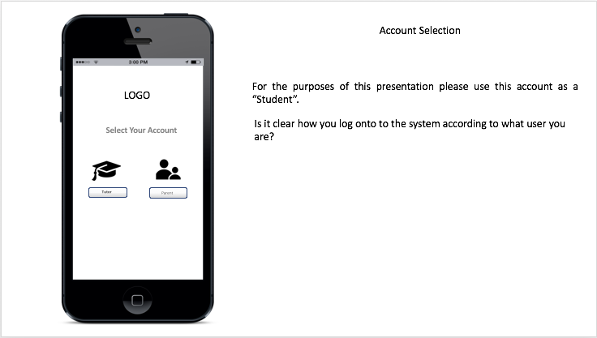

Figure : Account Selection screen

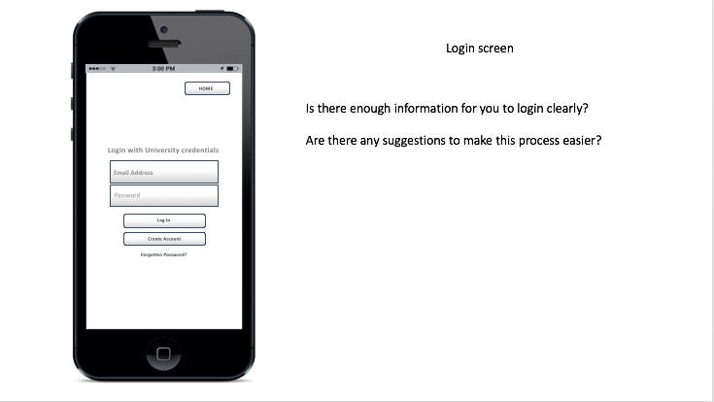

Figure : Login screen

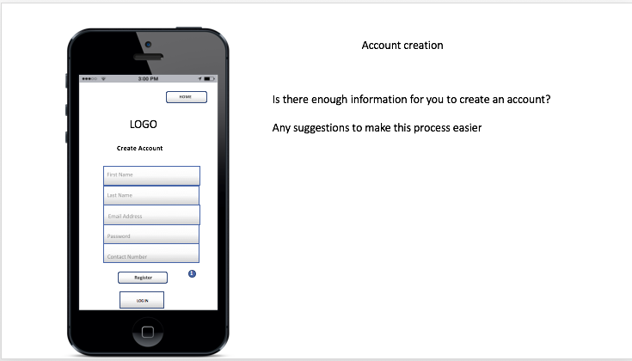

Figure : Account creation

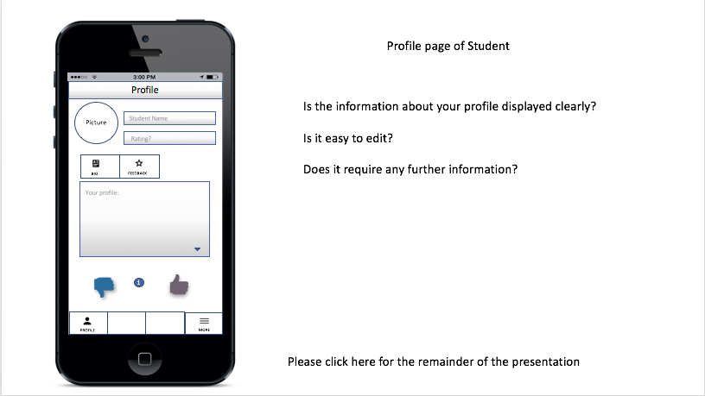

Figure : Profile page of student

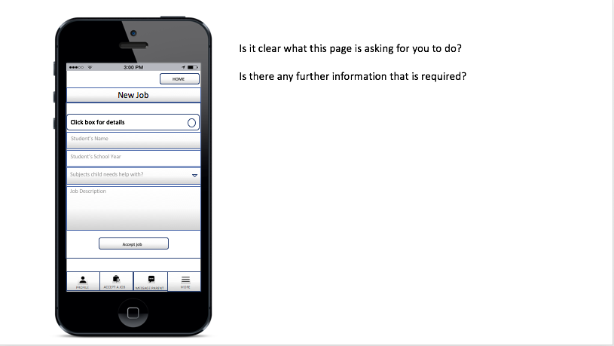

Figure : New job selection

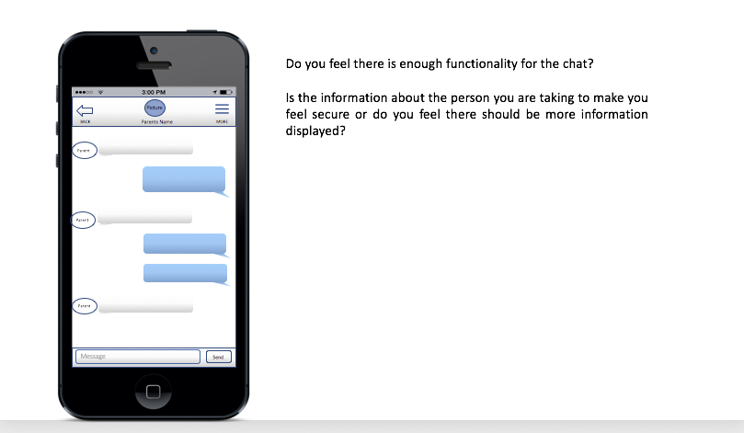

Figure : Instant message page

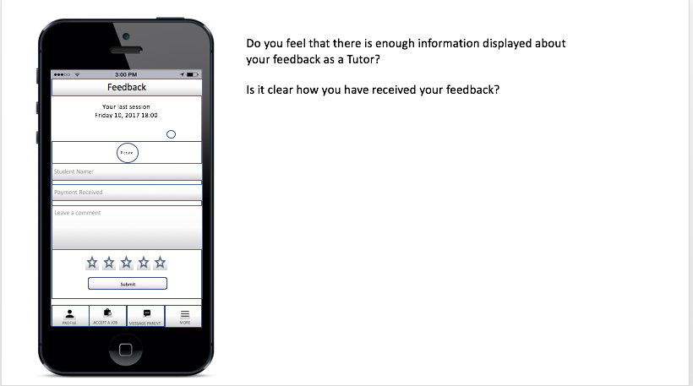

Figure : Feedback page

**Software project Market Research feedback: Parent prototype**

Table : Parent prototype feedback

| Category | Question | Response |  |  |  |  |  |
| --- | --- | --- | --- | --- | --- | --- | --- |
|  | | *User 1* | *User 2* | *User 3* | *User 4* | *User 5* | *User 6* |
| Account Selection | Is it clear how you log onto the system according to what user you are? | Yes, I the find login procedure very simple and clear. | It looks very easy to access and understand as it clearly shows only two icons to click one for parent and one for tutor. | It is clear and looks easy. | It seems quite clear however if the tutor and parent icons were different colors It will be easy to see that they are two different accounts. | Yes, easy click on either student or parent very easy. | This looks very good. It’s very clear, only two icons and clearly shows the difference between the accounts from the icon logos. However there needs to be more color for more attraction. Overall looks very decent! |
|  | | |  |  |  |  |  |
| Login Screen | Is there enough information for you to login clearly? | Yes, enough information to login clearly. | Yes, enough information to login clearly. | Seems very quick and easy to login! | Yes, it’s fine. If there was a box to put my students name in or my name in it would be a lot better. | Enough and very simple only email and password. | You only need your email address and password which is very easy to follow. |
|  | Are there any suggestions to make this process easier? | It is simple and easy so I think it’s fine as it is. | Instead of email and password a ’Personal ID’ will be more suitable in my opinion. | No I think it is generally fine how it is. | Instead of an email there can be a username to enter instead. | No its fine. | Needs more color as said before and also instead of having an email to enter, if the page prompt you to put in your username or a ‘personal ID’ it will look more professional. |
|  | | |  |  |  |  |  |
| Account Creation | Is there enough information for you to create an account? | I think there is enough information to create and account. | Looks fine as it is. | There should be a box to fill in my child's information too. | There is enough information but if there was an option to make a username too it will be convenient so instead of putting my email on the login page I can enter in my username. | All information is there ☺ | Yes all it needs to is an option to make a username and a section to upload a profile picture. |
|  | Any suggestions to make this process easier? | No it is perfect. | No, I think it is perfect. | No seems simple to create an account. | It seems very easy just needs more color to catch the eye. | It is perfect for me. | It’s as easy as it can be there has to be enough information to provide as it is the sign up page. |
|  | | |  |  |  |  |  |
| Profile page of Tutor | Is the information about your profile displayed clearly? | The information is displayed clearly. | I think it is clear enough. | Very clear and thorough explanations. | I think the tutor page has enough information to be entered and will answer all of my questions. | Clear as it can get. | Yes there is the name of the tutor, and a picture of the tutor so it will help me spot who they are once they arrive. |
|  | Is it easy to edit? | The profile looks easy to edit. | Seems It will be fine to edit. | I wouldn't’t know how easy it is until testing out the working app. | Not sure if its easy, will need to use the app to see. | Not sure how to edit. | Not sure how easy it is to so I need to use the actual app to decide. |
|  | Does it require any further information? | I think a rating section should be added to the profile where you can see the previous rating of the tutor. | No that is all the information needed. | No its ok. | No there is enough info very happy with this page. | No all information is there. | I think there should be an option to contact the tutor either by email or phone number and that information should be displayed on their profile page. |
|  | | |  |  |  |  |  |
| Post a tutor request | Is it clear what this page is asking for you to do? | I think that it’s very clear. | The page is asking me to request a session with a tutor and is easy to do with the information provided. | This page makes it an easy process to book a lesson for my child. | The ‘Post a Job’ clearly shows me that I am about to request a session with a tutor. It tells me to enter all the information to help find me a tutor for my son. | This page Is asking me to contact tutor for possible session with my child so very clear thanks. | Yes as I can see this page is clearly asking me questions to help me book a session for my child. There is an option to choose which subject my child needs help on so automatically there will be a search finding a tutor who specializes in the subject I choose. Very good! |
|  | Do you feel that there is any further information that is required? | No I find it very easy to request a session for my child with the information provided. | No there is enough information. | No the information provided is enough for me. | If there was an option to leave my email address or phone number it will be better otherwise I wouldn't know if a tutor has got back to me or not. | No, all information is already there which is good. | No I think all the information provided is satisfactory. |
|  | | |  |  |  |  |  |
| User chat | Do you feel there is enough functionality for the chat? | I think there is enough functionality for the chat. | I think it’s fine how it is. | I think it is enough however if there was an option to call the tutor it will be a lot more useful. | The messaging service looks very simple and easy to use. | Chat section looks very neat and easy to use. | It seems like a basic messaging service. I’m use to this so it will be very easy for me to use. |
|  | Is the information about the person you are talking to make you feel secure or do you feel there should be more information displayed? | In case of anything illegal I think there should be a button where you can report anything. | It looks secure enough and a very convenient way to contact tutor. | There need to be an option to report anything suspicious. | There should be an option to call the tutor for updates also a button to report anything if there were supposedly something bad happening. | It seems ok but will not know how I will feel until I use it in real life. | Yes there needs to be an option for me to call the tutor if I needed to know anything as a phone call is a lot more easier and clearer to exchange information and understand over text. Also if there is an emergency or anything dangerous occurring there should be a ‘report’ button. Otherwise I will be worried about mine and my child’s safety. |
|  | | |  |  |  |  |  |
| Feedback page | Do you feel that there is enough information displayed about the feedback of the tutor? | Yes, enough information | There is sufficient information detailed. | Looks very good. | Looks great! | Yes, but needs a button to contact tutor. | This page looks fantastic. There isn't much more I can think of to add very good! |
|  | Is it clear how you need to feedback information? | Yes, clear. | I think is clear as it can get. | This page gives me enough information to provide a feedback for all tutors. | This page looks like it will be very clear and easy to use thank you. | Yes very clear just need to enter 3 things and rate tutor out of 5 stars and submit. | Yes crystal clear! ☺ |
| Logo Choice |  |  |  |  |  |  |  |
| Name Choice |  |  |  |  |  |  |  |

A full breakdown of how the logo and name choices were decided by our users.

**Logo feedback**

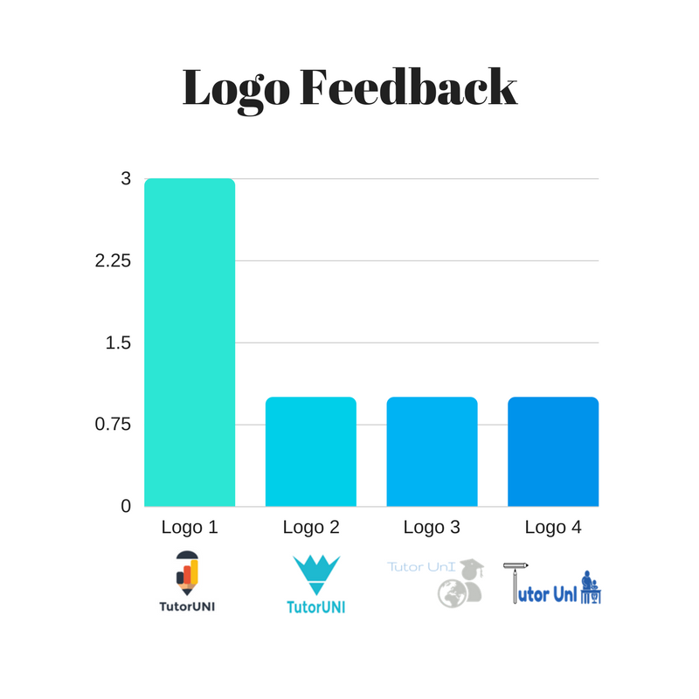

Figure : Logo Feedback

**Name Feedback**

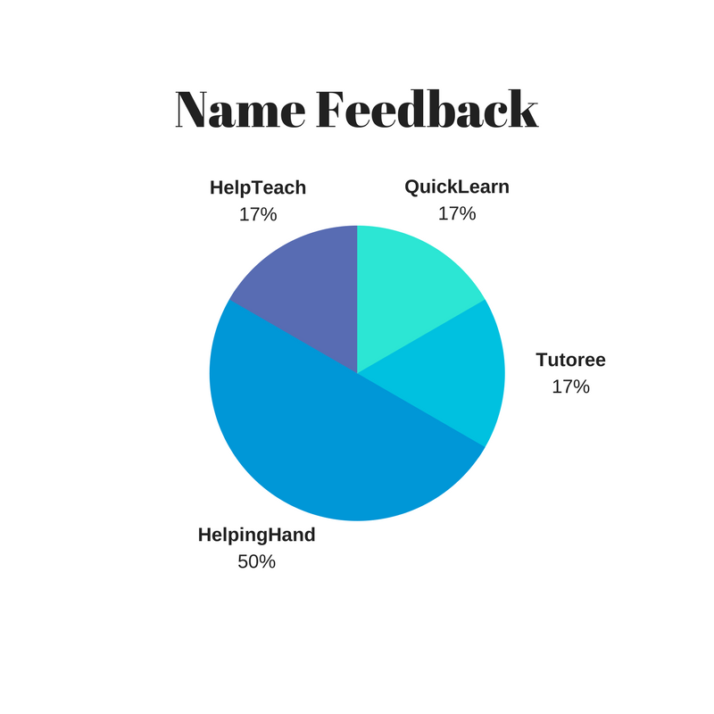

Figure 29: Name Feedback

#### Technical prototyping – MVP

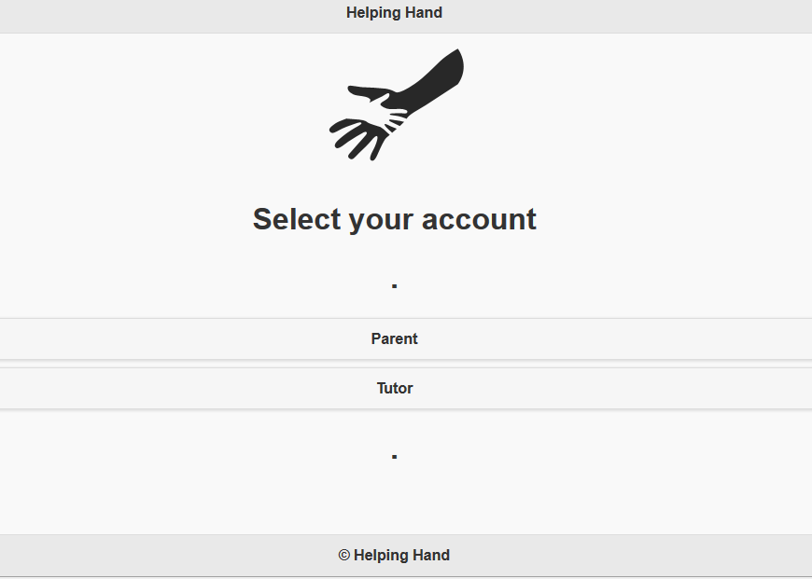

Figure : Home page of technical prototype

**Parent technical Prototype**

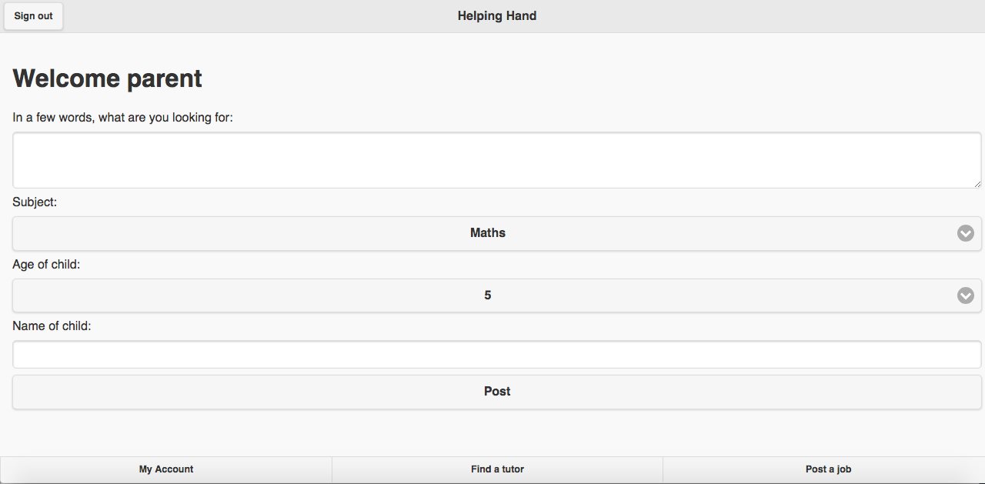

Figure : Welcome page for parents

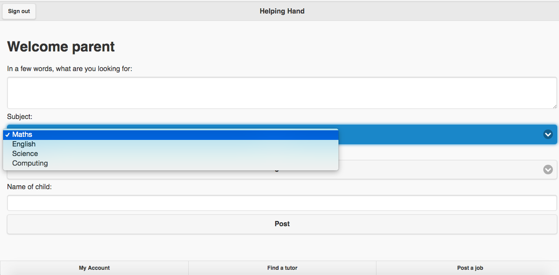

Figure : Profile of child and teaching requirements

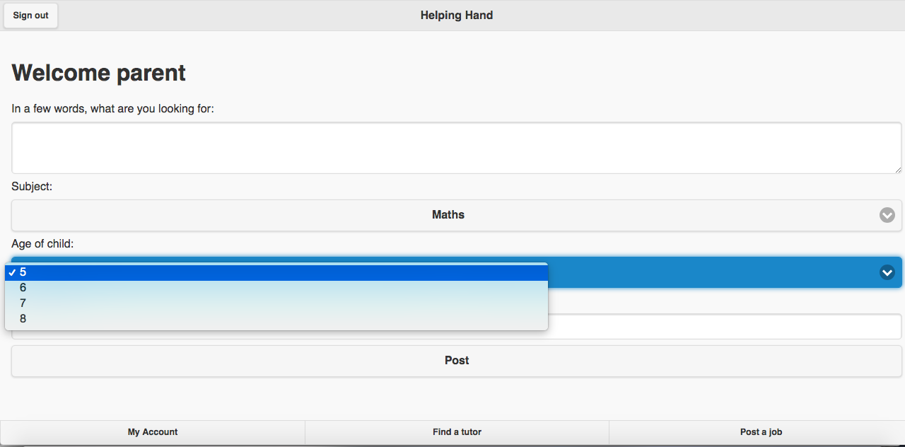

Figure : Selection options

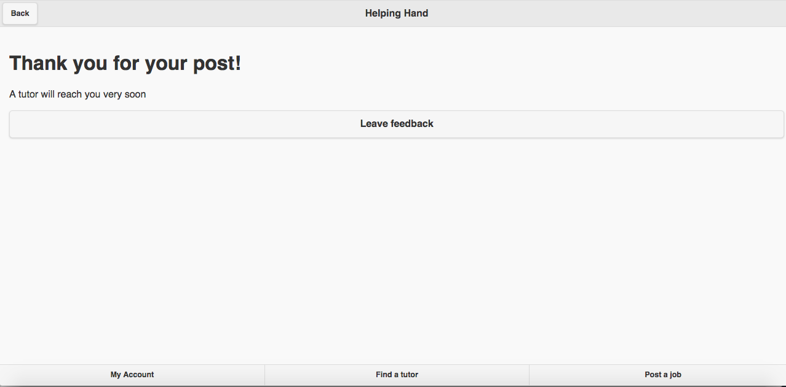

Figure : Acknowledgement page

**Tutor Technical Prototype**

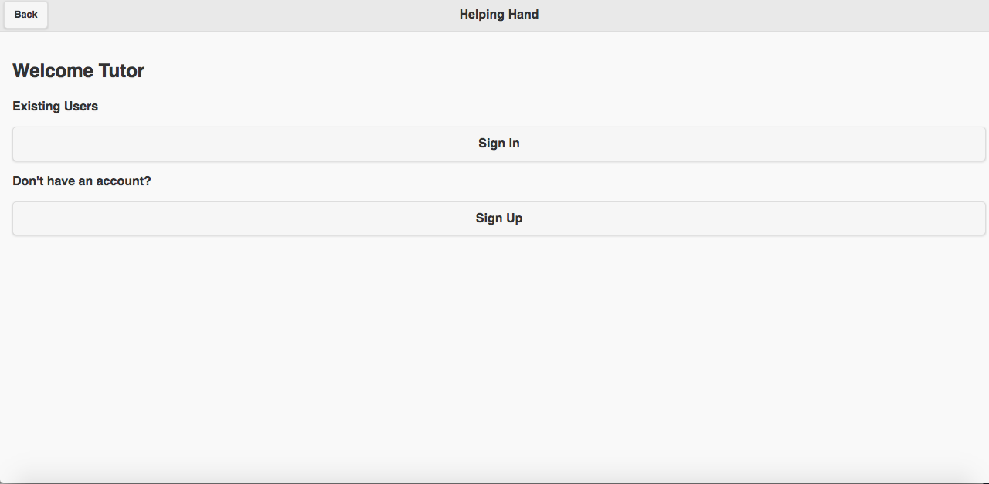

Figure : Welcome page for tutor login

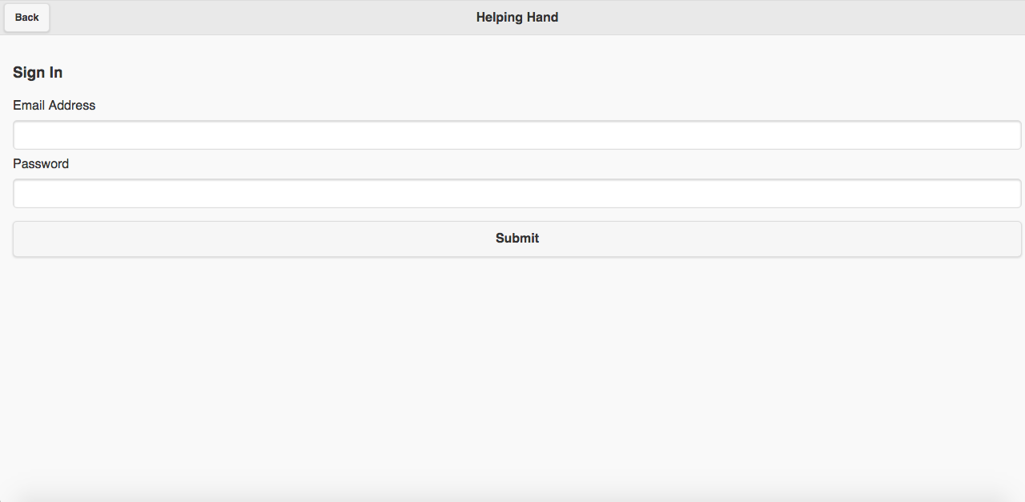

Figure : Tutor login page

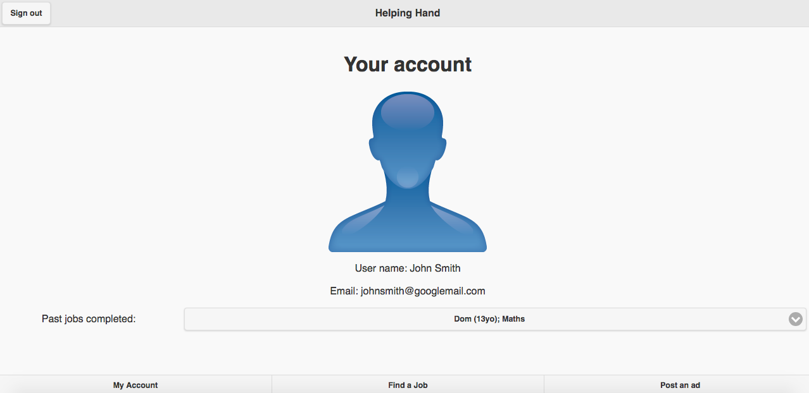

Figure : Profile page of tutor

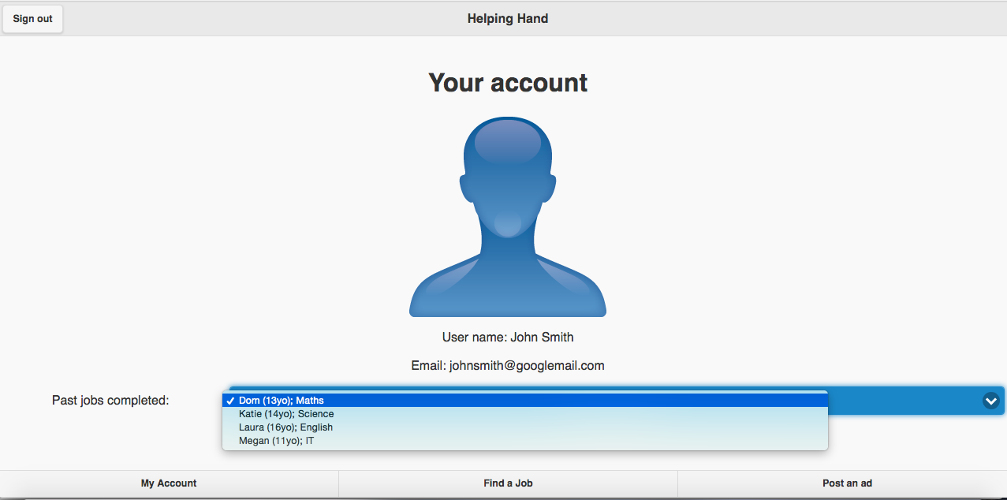

Figure : Previous jobs that have completed by the tutpr

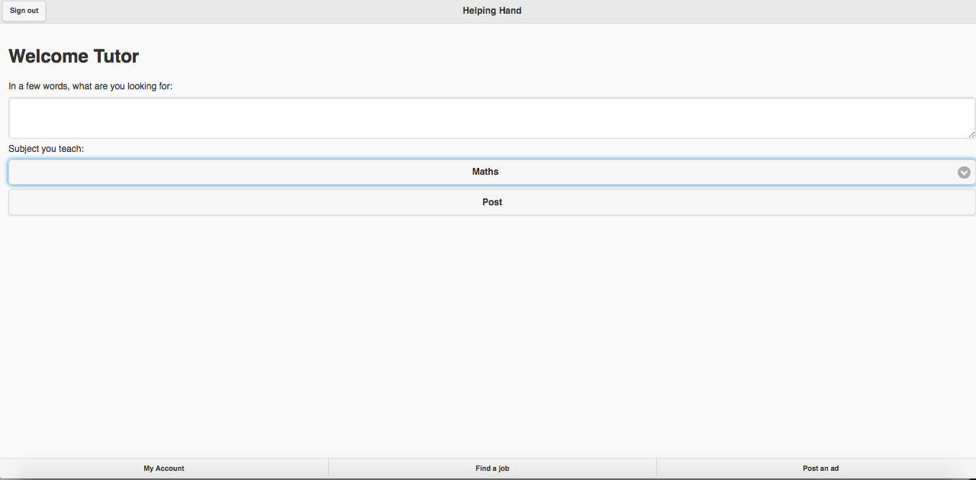

Figure : Welcome page for tutor

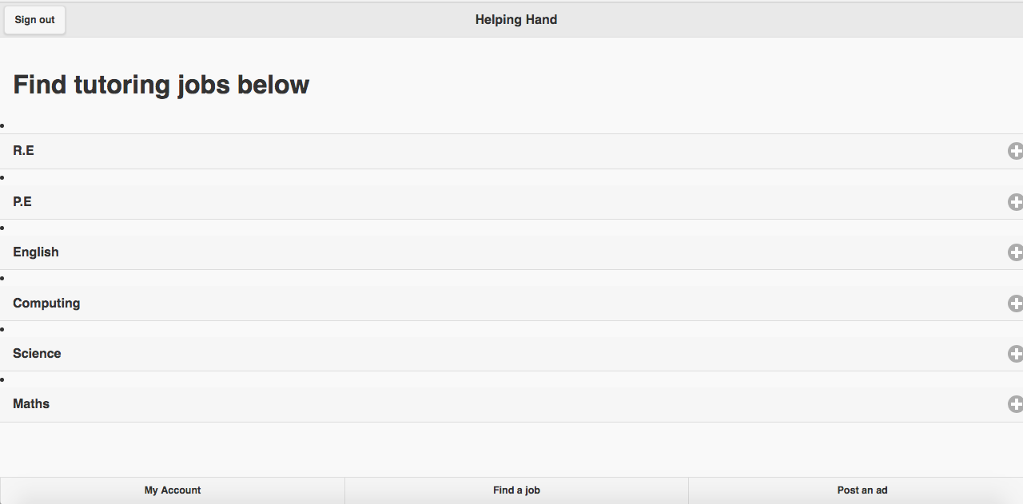

Figure : Job selection page

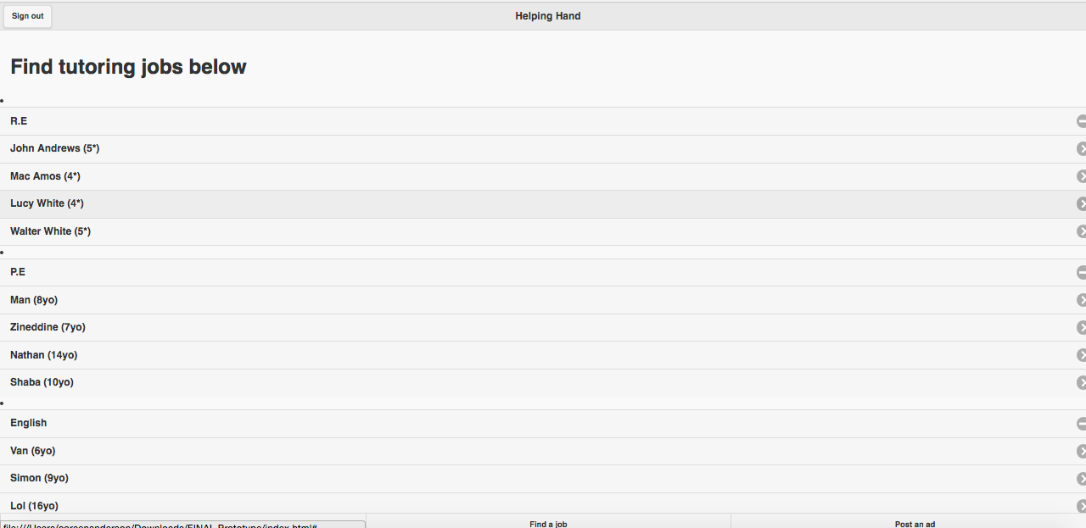

Figure : Job categories for tutors

#### Minutes of weekly meetings

Table : Minutes of meeting (6 October 2017)

|  |  |
| --- | --- |
| Minutes of Group B meeting held on 6th October 2017 at 11:00am  The meeting was held at Goldsmiths SU Bar, 10 Dixon Road, London SE14 6NW | |
| **Present:** |  |
| Aman Ahmed (AA) | Team member |
| Fahim Ahmed (FA) | Team member |
| Zineddine Daif (ZA) | Team member |
| Ali Elzalmy (AE) | Chair |
| Coreen John (CJ) | Team member |
| Aaron Meressie (AM) | Team member |
| Benji Misner (BM) | Team member |
|  |  |
| Apologies |  |
| No apologies |  |
|  |  |
|  |  |

1. Welcome

AE welcomed everybody to the meeting. It was decided amongst the team that we should meet weekly so that we could all meet together and set weekly targets for the group so that we can meet our project targets.

It was suggested that we should meet for an hour on Friday mornings so that we can update the group on how we have progressed through the meeting.

The next meeting was set for 13 October 2017.

Table : Minutes of meeting (13 October 2017)

|  |  |
| --- | --- |
| Minutes of Group B meeting held on 13th October 2017 at 11:00am  The meeting was held at Goldsmiths SU Bar, 10 Dixon Road, London SE14 6NW | |
| **Present:** |  |
|  |  |
|  |  |
| Zineddine Daif (ZA) | Team member |
| Ali Elzalmy (AE) | Chair |
| Coreen John (CJ) | Team member |
| Aaron Meressie (AM) | Team member |
| Benji Misner (BM) | Team member |
|  |  |
| Apologies |  |
| Aman Ahmed (AA) | Team member |
| Fahim Ahmed (FA) | Team member |
|  |  |

1. Welcome

AE Welcomed everybody to the meeting. We reviewed some of the task that were set such as the research document and all the work that was completed. We decided to review some of the tasks such as pros/cons list in the meeting. We set the next task which included concept statement, and to confirm the stake holders. Everyone present agreed to their individual tasks.

The next meeting was set for 20 October 2017.

Table : Minutes of meeting (20 October 2017)

|  |  |
| --- | --- |
| Minutes of Group B meeting held on 20th October 2017 at 11:00am  The meeting was held at Goldsmiths SU Bar, 10 Dixon Road, London SE14 6NW | |
| **Present:** |  |
| Aman Ahmed (AA) | Team member |
| Fahim Ahmed (FA) | Team member |
| Zineddine Daif (ZA) | Team member |
| Ali Elzalmy (AE) | Chair |
| Coreen John (CJ) | Team member |
| Aaron Meressie (AM) | Team member |
| Benji Misner (BM) | Team member |
|  |  |
| Apologies |  |
| No apologies |  |
|  |  |
|  |  |

1. Welcome

AE Welcomed everybody to the meeting. We had a few tasks this week assigned to us. They included:

* + - * Concept statement
      * Confirm the stakeholders
      * Confirm how information will be handled
      * Produce a preliminary use case
      * Create a UML

In the meeting we discussed who will take each tasks and we had to complete by our lab next Tuesday, where we will review the material.

This was all recorded as our budgets and for this week the task took a total of 9.5.

The next meeting was set for 3 November 2017.

Table : Minutes of meeting (3 November 2017)

|  |  |
| --- | --- |
| Minutes of Group B meeting held on 3rd November 2017 at 11:00am  The meeting was held at Goldsmiths SU Bar, 10 Dixon Road, London SE14 6NW | |
| **Present:** |  |
| Aman Ahmed (AA) | Team member |
| Fahim Ahmed (FA) | Team member |
| Zineddine Daif (ZA) | Team member |
| Ali Elzalmy (AE) | Chair |
| Coreen John (CJ) | Team member |
| Aaron Meressie (AM) | Team member |
| Benji Misner (BM) | Team member |
|  |  |
| Apologies |  |
| No apologies |  |
|  |  |
|  |  |

In the meeting we discussed who will take each tasks and we had to complete by our lab next Tuesday, where we will review the material.

The task that were set:

* + - * Research competitors
      * Research legal and regulations
      * Research academic documents and statistics
      * Develop market personas

This was all recorded as our budgets and for this week the task took a total of 10.5.

The next meeting was set for 10 November 2017.

Table : Minutes of meeting (10 November 2017)

|  |  |
| --- | --- |
| Minutes of Group B meeting held on 10th November 2017 at 11:00am  The meeting was held at Goldsmiths SU Bar, 10 Dixon Road, London SE14 6NW | |
| **Present:** |  |
| Aman Ahmed (AA) | Team member |
| Fahim Ahmed (FA) | Team member |
| Zineddine Daif (ZA) | Team member |
| Ali Elzalmy (AE) | Chair |
| Coreen John (CJ) | Team member |
| Aaron Meressie (AM) | Team member |
| Benji Misner (BM) | Team member |
|  |  |
| Apologies |  |
| No apologies |  |
|  |  |
|  |  |

1. Welcome

In the meeting we discussed who will take each tasks and we had to complete by our lab next Tuesday, where we will review the material.

The task that were set:

* + - * Assess management tools.
      * Research which tool is best for Gantt chart.
      * Identify Conceptual prototype
      * Develop market personas

This was all recorded as our budgets and for this week the task took a total of 8.5.

The next meeting was set for 17 November 2017.

Table : Minutes of meeting (17 November 2017)

|  |  |
| --- | --- |
| Minutes of Group B meeting held on 17th November 2017 at 11:00am  The meeting was held at Goldsmiths SU Bar, 10 Dixon Road, London SE14 6NW | |
| **Present:** |  |
| Aman Ahmed (AA) | Team member |
| Fahim Ahmed (FA) | Team member |
| Zineddine Daif (ZA) | Team member |
| Ali Elzalmy (AE) | Chair |
| Coreen John (CJ) | Team member |
| Aaron Meressie (AM) | Team member |
| Benji Misner (BM) | Team member |
|  |  |
| Apologies |  |
| No apologies |  |
|  |  |
|  |  |

1. Welcome

In the meeting we discussed who will take each tasks and we had to complete by our lab next Tuesday, where we will review the material.

The task that were set:

* + - * Develop prototype for students
      * Develop prototype for parents
      * Draw logos
      * Develop the questions to ask

This was all recorded as our budgets and for this week the task took a total of 8.5.